

**Fall**

23

08

**Fall**

**TRANSFORMING OIL PRODUCTION WITH DATA DRIVEN ANALYTICS**

**Final Project Report**

**DSO 545- Statistical Computing and Data Visualization**

December 2, 2023

Prepared For: Francis Pereira

**Group Members**

Naif Alnahash

Riley Sansone

Antares Wong

Harshit Bhavnani

Jnana Kundur Prakash

# **EXECUTIVE SUMMARY**

This report presents a comprehensive analysis of a selected area within the Wattenberg Field, NE Colorado, based on geostatistical and production data from 137 wells producing from 1999-2022. This data was collected from Colorado Oil and Gas Commission. The objective is to leverage advanced analytics to identify a potential drilling location and predict oil production rate by identifying the correlation between oil production and geostatistical data to enhance profitability of the operators in the area of interest while meeting the increase in demand of oil.

Based on the study, the estimated **original oil reserves is 167 million barrels (Mbbl)** and the **remaining reserves is 150 Mbbl**. The **oil production rate** was found to be **averaging 58 barrels per day (bpd) and a median of 46 bpd**. Then, the wells were classified based on performance and locations, offering valuable insights into production across different areas of the field. It was found that **49% of the wells are average producing wells** and **39% are high producing wells.**

Interpolation techniques were utilized to populate geostatistical values between existing wells to identify sweet spots of potential drilling locations. A drilling location in the northeast of the field is proposed, surrounded by high-producing wells and located in a geostatistical sweet spot. Utilizing a regression model based on the porosity, a prediction of **100 bpd oil production is estimated** at the identified location with estimated oil price of $75/bbl. An economic analysis projected a profitable outcome, with an estimated **net profit of close to $7 million over a 5-year period post-drilling**, which accounts for expenses, including taxes, capital expenditure, royalties, and operating costs. This data-driven analytics shows the projected profit of drilling the proposed well. Further analysis with advanced petroleum engineering is required to capture production decline and have additional rock and dynamic data to have more accuracy of the model.

**Table of Contents**

***EXECUTIVE SUMMARY 2***

***OBJECTIVES & BUSINESS QUESTION 4***

***INTRODUCTION & DATASET 5***

**DATA LIMITATION 8**

***APPROACH 9***

***METHODOLOGY & RESULTS DISCUSSION 10***

**DATA PREPARATION & IMPORT 10**

**DATA MERGING 10**

**DESCRIPTIVE DATA 10**

**ESTIMATING OIL RESERVES 15**

**ORIGINAL OIL IN PLACE (OOIP)** 15

**REMAINING RESERVES ESTIMATION** 15

**WELL PRODUCTION CLASSIFICATION 16**

**Correlation Matrix 19**

**PROPOSED LOCATION FOR INFILL DRILLING 20**

**OIL PRODUCTION RATE PREDICTION 23**

**ECONOMIC ANALYSIS 25**

***CONCLUSION 28***

***References 30***

# **OBJECTIVES & BUSINESS QUESTION**

The project target is to leverage analytics to provide a data driven recommendation for drilling a new oil well in an ideal location within the selected area in the Wattenberg Field in northeast of Colorado. This is to be achieved while optimizing oil production and maximizing the Net Present Value (NPV) over a period of five years. The objectives outlined below are considered to leverage analytical methodologies and insights:

1. **Analytical of Historical Data:**
   * Execute a comprehensive analysis of historical production and geostatistical data to identify patterns to understand the field’s production performance and factors affecting the production.
2. **Geostatistical Analytics for Informed Drilling Decisions:**
   * Establish a correlation between oil production and geostatistical data to identify the factors impacting oil production.
   * Apply interpolation and data analytics to extrapolate a detailed geostatistical landscape, enabling the identification of a potential drilling location ensuring a comprehensive understanding of the potential oil production and geological conditions prior drilling a multi-million-dollar oil well.
3. **Predictive Analytics for Economic Optimization:**
   * Develop predictive models to forecast potential oil outputs, incorporating economic parameters to evaluate financial returns from the proposed drilling location.

# **INTRODUCTION & DATASET**

Global oil demand is projected to increase by 10% by 2028 and 16% by 2045 compared to the demand in 2022 (OPEC). Therefore, there is a need for additional oil production resources, which can be achieved by drilling new wells. The process of selecting a new oil well involves comprehensive analytics of the production and geostatistical data to select a data-driven site for an optimal economic judgment of the asset. The geostatistical data impacts the oil production, and the goal is to determine which parameters are contributing to oil production performance. Python was used to ultimately perform a model to analyze a subdivision of the DJ basin in Wattenberg Field located northeast of Colorado. The asset of interest lies in range 65W and township 3N (Sections: 25, 26, 27, 34, 35 & 36). The maps show the location of the field, and the locations of the wells were plotted to see the well distribution across the area.

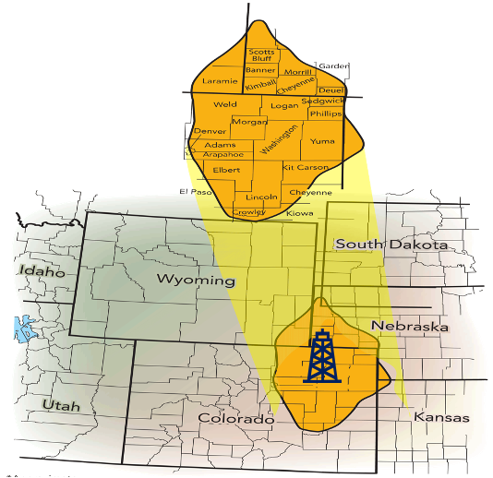

*Figure 1: Wattenberg Field Location*

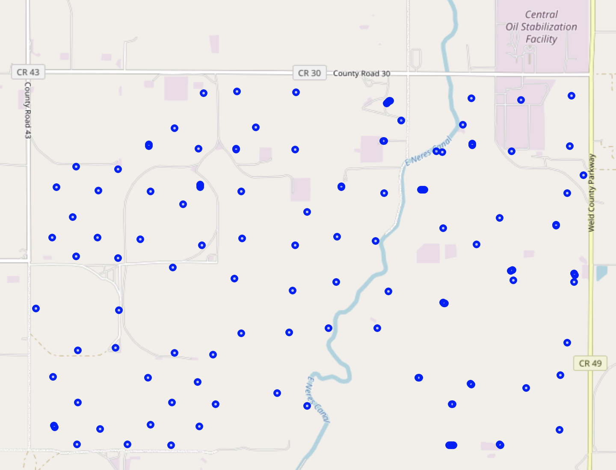

*Figure 2: Plotted Wells Location*

Generally, petroleum modeling engages two extensive aspects of data and that includes geostatistical data (field measurements) and dynamic data (historic production information). Integration of these two components is very crucial in the analysis. The team analyzed the wells data collected from Colorado Oil and Gas Conservation Commission website (COGCC), which serves as an input for the model to understand the production performance, investigate the relationships between geostatistical data and oil production to identify trends, correlations and sweet spots to predict future new wells production to estimate the profit. The two datasets are described below:

1. **Production Data**

* **Well No.**: The identification number of the well.
* **Total Days of Production**: The total number of days the well has been in production.
* **Total Oil Production**: The total amount of oil produced from the well (barrels).
* **Oil Rate**: the average oil production rate per day (barrels per day - bpd).
* **Water Production**: The amount of water produced from the well (bpd). However, the study will focus only on oil production.

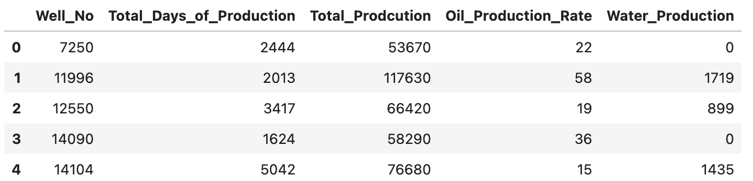

*Figure 3: Example of Production Dataset Head*

1. **Geostatistical Data**

* **Well No.**: The identification number of the well.
* **Latitude**: The latitude coordinate of the well's location.
* **Longitude**: The longitude coordinate of the well's location.
* **Well_Depth**: The total depth of the well.
* **Top_Depth**: The depth to the top of the reservoir - producing zone.
* **Bottom_Depth**: The depth to the bottom of the reservoir - producing zone.
* **Pay_thickness**: The thickness of the pay zone, which is the portion of the reservoir that contains hydrocarbons (Bottom – Top Depth)
* **Porosity**: A measure of the reservoir's ability to hold fluid.
* **Water Saturation**: indicating the proportion of the reservoir's pores filled with water.
* **Permeability:** the ability of the fluid to flow within the rock.

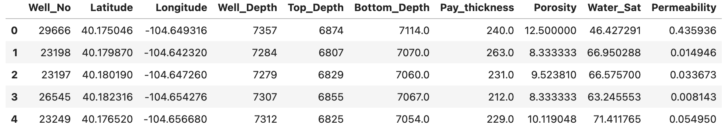

*Figure 4: Example of Geostatistical Dataset Head*

The analysis will focus on the primary geostatistical data (porosity, water saturation, permeability and thickness) and how they impact the production rate and then correlate them to predict future production rate.

## **DATA LIMITATION**

In preparing our data for analysis, several limitations were encountered, leading to necessary assumptions to proceed with the analysis effectively:

* **Constant Production Rate Assumption**: The dataset provided total oil production figures for each well, without a detailed time series. Due to the absence of this data, we were unable to analyze production decline curves over time. Therefore, we assumed a constant production rate across the lifetime of each well to simplify the analysis.
* **Homogeneity of Wells**: Detailed drilling completion reports were not accessible for our analysis. Therefore, information on specific downhole accessories, well intervention techniques such as stimulation (acid pumping), or hydraulic fracturing, which can impact production, was missing. Therefore, all wells were treated as homogeneous in terms of production capability. This approach does not account for possible variations in well performances due to different drilling and completion strategies.
* **Advanced Petroleum Engineering Factors**: Key petroleum engineering variables such as reservoir pressure, depletion rate, and fluid viscosity were not included in the available dataset. These factors can have a significant impact on production efficiency and well lifespan. Their absence means that our analysis primarily focuses on effective volume and initial production metrics, which are treated as representative of the average production rate for each well.

While these limitations restrict the depth of the analysis, the available data still offers valuable insights into the effective volume and initial production rates. By considering these as representative of the average production rate, we can have meaningful conclusions and recommendations for the field. However, advanced petroleum engineering simulations are needed in a real-world context.

# **APPROACH**

A systematic approach is taken to go over the process and development of this project to achieve the final results and requires as below:

**Data Preperation & Analysis**

Collecting production and geostatistics data.

Descriptive data analysis.

**Reserve Estimation**

Estimate Orginal Oil in Place (OOIP) based on avergae geostatistical data.

Calculate the the total produced oil and remaining reserves.

**Production Analysis**

Analyze overall oil production rate.

Classify the wells based on oil production rate.

Analyze production rate based on quadrant.

Analyze geostatistical data based on the oil production rate classification and quadrant.

Correlate between geostatistical data and oil rate production

**Infill Drilling**

I nterpretate geostatistical data to identify sweet spots to drill a new oil well.

Utilize regression to predict the oil rate production for the proposed location.

Perform economic analysis to estimate the profit after 5 years.

# **METHODOLOGY & RESULTS DISCUSSION**

## 

## **DATA PREPARATION & IMPORT**

The datasets include 137 oil wells across the area of interest and contain production and geostatistical values. The team reviewed the data and found that:

* All the wells have production data.
* 14 wells are missing porosity, water saturation and permeability.

To maintain our geostatistical analysis, we included these 14 wells within the production dataset due to their valuable production output, but to exclude them from the geostatistical interpretation. Therefore, the data preparation and cleaning phase was critical to ensure that our analyses would be both comprehensive in terms of production and geostatistical terms.

## **DATA MERGING**

To start building the model the geostatistical and production data are imported and identify all relevant data to interpolate it as we go through the process of developing the model. As we have two datasets, merging both datasets were essential for our comprehensive analysis. By using "Well Number" as a key identifier, we combined the two datasets to correlate production with geostatistical data. This allowed us to analyze the impact of geological characteristics on oil production.

## **DESCRIPTIVE DATA**

To start with the analysis of our area of interest, a descriptive analysis was performed. This process involved collecting basic geostatistical details such as the range, mean, median values of both geostatistical and production data. Our approach was to simplify complex data into clear, visual formats – including charts and graphs – that describe the trends and variances. The primary goal was to build a clear picture of the selected part of the field, which would act as a guide for identifying regions with the highest potential of oil production. This stage is important as it sets the groundwork for future steps, ensuring that any decisions made are informed and data driven.

*Table 1: Descriptive Data*

|  |  |  |  |  |  |  |  |  |
| --- | --- | --- | --- | --- | --- | --- | --- | --- |
|  | **Well_Depth** | **Top_Depth** | **Bottom_Depth** | **Pay_thickness** | **Porosity** | **Water_Sat** | **Permeability** | **Production Rate** |
| **count** | 137 | 137 | 137 | 137 | 123 | 123 | 123 | 137 |
| **mean** | 8,009 | 6,898 | 7,114 | 216 | 11.25 | 55.52 | 0.24 | 58 |
| **std** | 1,511 | 163 | 159 | 36 | 2.70 | 9.48 | 0.33 | 44 |
| **min** | 7,175 | 6,722 | 6,932 | 91 | 6.55 | 40.12 | 0.00 | 4 |
| **25%** | 7,286 | 6,824 | 7,040 | 196 | 8.93 | 47.86 | 0.02 | 31 |
| **50%** | 7,725 | 6,847 | 7,065 | 215 | 10.73 | 56.14 | 0.05 | 46 |
| **75%** | 7,845 | 6,896 | 7,121 | 240 | 13.34 | 61.64 | 0.43 | 70 |
| **max** | 16,651 | 7,921 | 8,077 | 335 | 16.99 | 78.99 | 1.45 | 277 |

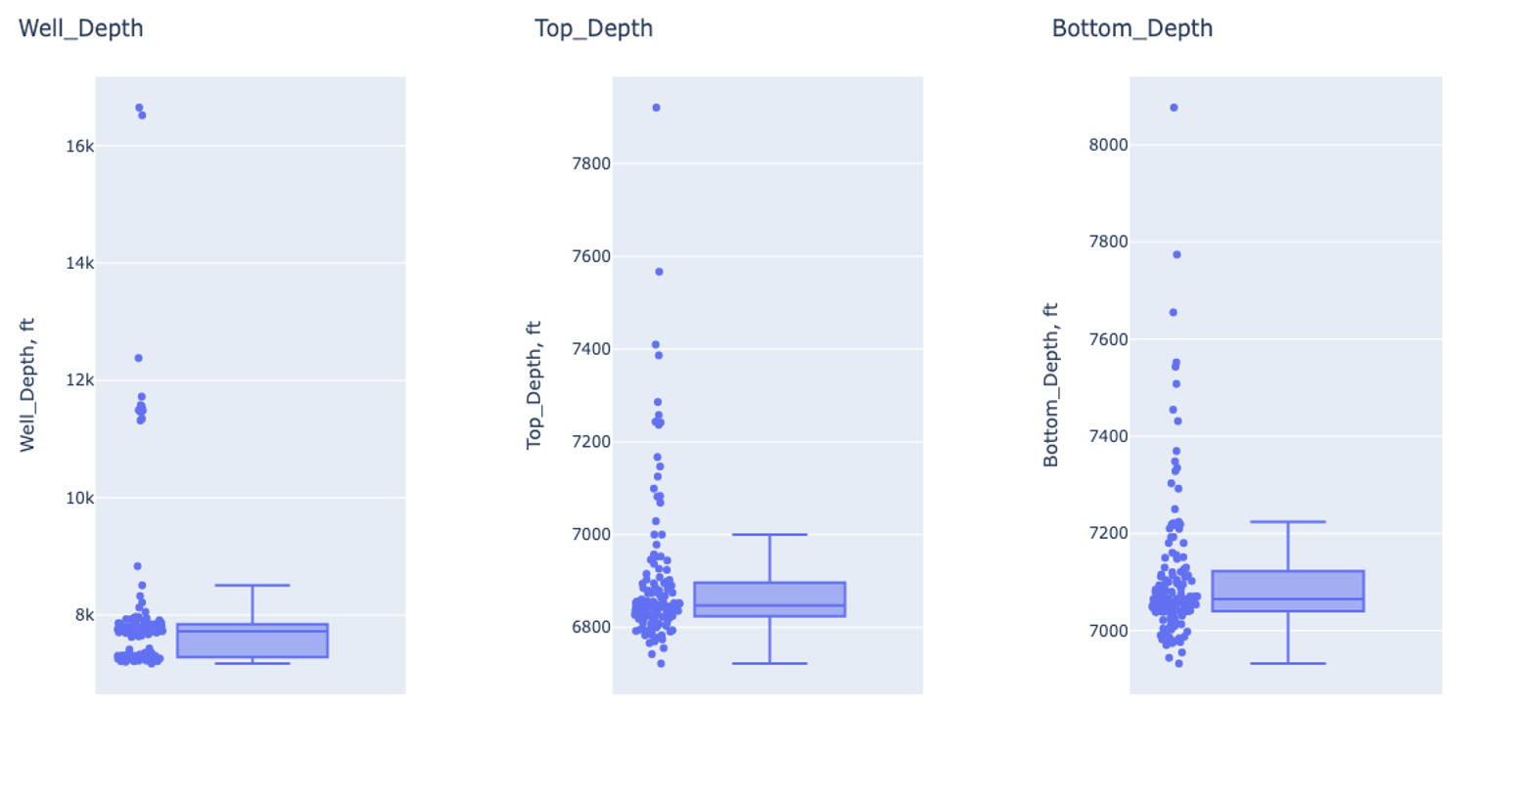

*Figure 5: Well Depths Box Plots*

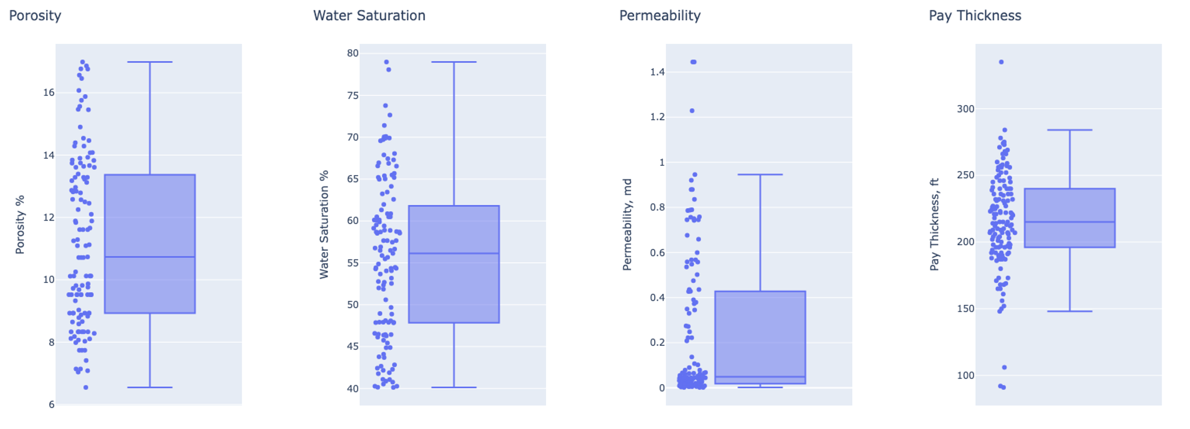

*Figure 6: Geostatistical Data Box Plots*

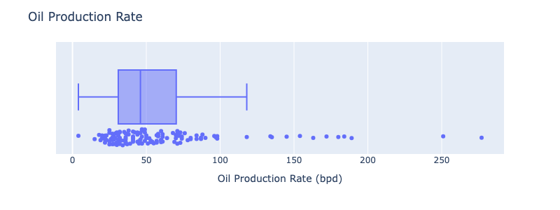

*Figure 7: Production Rate Box Plot*

The comprehensive descriptive analysis of the geostatistical production data provides significant insights into the geological characteristics of the selected area of the oil field. The key findings are outlined as follows:

* **Well Depth:** The drilling depth for a typical well span from 7,286 to 7,845 feet. There are exceptions with some wells reaching deeper depths, likely targeting deeper geological formations for exploratory drilling and evaluation.
* **Reservoir Thickness**: The average thickness of the reservoir is calculated to be around 216 feet. This parameter is crucial as it contributes to the estimation of the total oil reserves available in the area.
* **Porosity:** The average porosity stands at 11.25%, indicating the percentage of the rock that could potentially hold hydrocarbons. This is a vital factor in determining the storage capacity of the reservoir.
* **Water saturation:** The average water saturation is 55.5% and this measurement provides insights into the portion of the pore space filled with water as opposed to hydrocarbons and impacts the calculation of recoverable oil reserves.
* **Permeability:** The area shows an average permeability of 0.24 millidarcy with a maximum of 1.45 mD. Generally, the low permeability suggests that the reservoir rock has low ability to flow, indicating that the formation is considered tight. Consequently, this suggests that production rates across the area might be on the lower end due to the restricted flow of fluids through the reservoir rock.

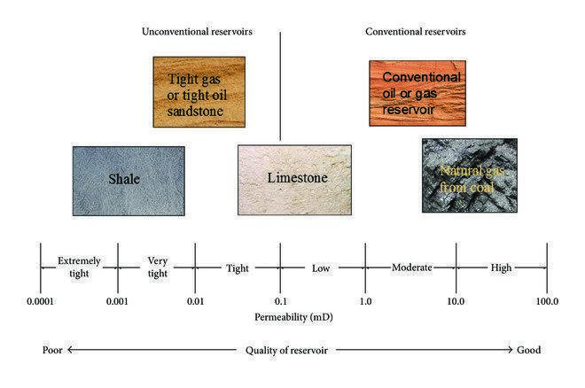

*Figure 8: Reservoir Quality – Permeability*

* **Production Rate:** The oil production rate among the wells varied significantly, ranging from as low as 4 bpd to as high as 277 bpd. This wide range indicates a considerable variation in well performances within the area. The average production rate across the wells stood at 58 bpd, while the median was slightly lower at 46 bpd. This supports the previous insight of lower production rate due to the tight rock behavior in the area. However, although the production rate is considered low, it is still above the national average production rate of 30 bpd (eia report). This indicates that, on average, the wells in this area are more productive than the national norm. This above-average productivity highlights the strategic importance of this area within the oil field. It suggests that further exploration and investment in this area could yield profitable outcomes. While the data provides a clear picture of the production rates, further analysis could benefit from exploring the factors contributing to this above-average performance.

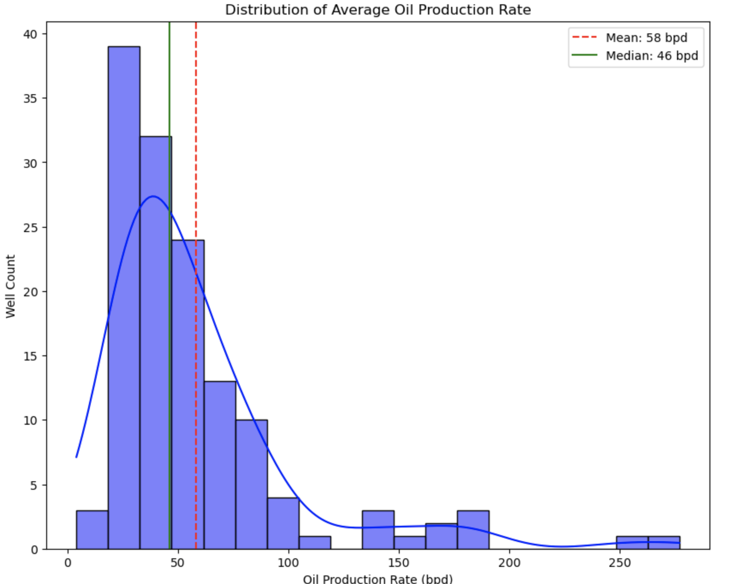

*Figure 9: Oil Production Rate Histogram*

These geostatistical and production parameters provide a foundational understanding of the subsurface conditions, which is required for making informed decisions regarding future drilling and production strategies. The findings indicate that while the reservoir has a reasonable thickness and porosity, the tight nature of the formation could require more recovery techniques by production engineering to optimize oil production.

## **ESTIMATING OIL RESERVES**

**ORIGINAL OIL IN PLACE (OOIP)**

The estimation of oil reserves within the chosen area of the Wattenberg Field starts with the calculation of the Original Oil in Place (OOIP), which represents the quantity of oil (barrel) reserves at the discovery. We used the volumetric method for this purpose, considering the area of the reservoir, average net pay thickness, average porosity, average water saturation, and oil formation volume factor. The total OOIP is 167 million bbl. (CSUG/ SPE 149471)

$Initial Oil in Place =\frac{7758 \left(ϕ\right)\left(h\right) \left(A\right)(1-S_{w})}{ (B_{oi})} bbl$

* A = Area of the reservoir which is 2,585 acres (estimate base on earthpoint website)
* h = Average pay thickness from the dataset = 216 ft.
* $ϕ$: Average porosity from the dataset = 11.25%
* $S_{w}$: Average water saturation from the dataset = 55.5%.
* $B_{oi}$: Oil formation volume factor which is 1.3 (USGS report/ study by Mines)

|  |
| --- |
| **Estimated Initial Oil in Place** |
| **167 Million barrels of oil** |

**REMAINING RESERVES ESTIMATION**

To estimate the remaining reserves, the production from the production dataset of activities to the present was calculated. This involved compiling cumulative production figures and subtracting them from the OOIP to calculate the volume of oil still available for extraction. The remaining reserves offer insight into the future potential of the field and inform decisions regarding additional drilling and development strategies.

Total produced is 17 million and remaining 150 million bbl and the remaining reserves shows that there is still 90% of oil to be produced, indicating the potential of drilling more oil wells to maximize the recovery of the field and generate more profit.

$$Remaining Reserves=OOIP- total produced oil$$

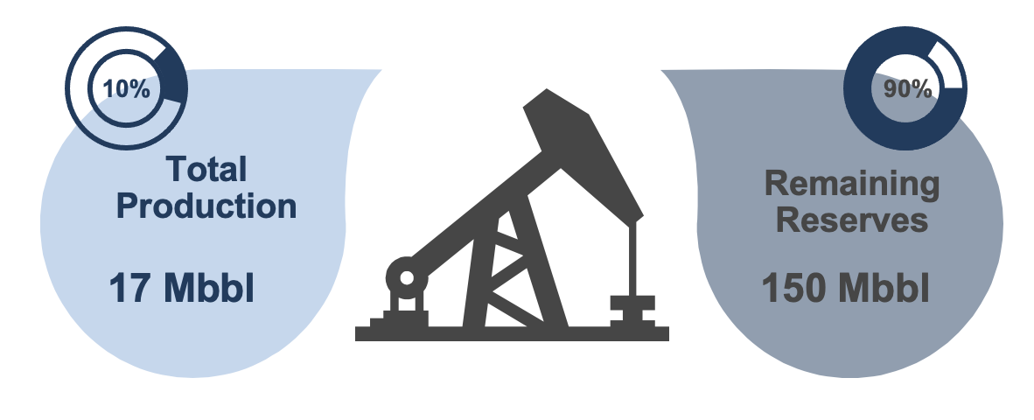

*Figure 10: Total Production & Remaining Reserves*

## **WELL PRODUCTION CLASSIFICATION**

After assessing the production trends, we classified the wells into three categories based on their output compared to national and field averages:

* **Low Production Wells**: The minority of the field, with 16 wells or 12% of the total, are categorized as low producers. These wells have output rates below the national average of 30 barrels per day (bpd). They are critical to identify underperformance or wells nearing the end of their productive life.
* **Average Production Wells**: Comprising the majority of the field, 67 wells, or approximately 49% of the total, have production rates that fall within the average range. Those wells are falling between the national production average and the field average, with production rates from 30 to 60 bpd, representing the standard operational performance and are essential for maintaining steady field output.
* **High Production Wells**: These wells are crucial for consistent field output and represent standard operational performance. Any well exceeding the field average with a production rate above 60 bpd is considered a high producer. Such wells suggest better reservoir properties and effective drilling and completion strategies, marking them as key contributors to the field’s overall productivity.

This classification highlights the field's productive diversity, with a substantial number of high-performing wells that could be potential drilling locations. The wells are plotted on the map below.

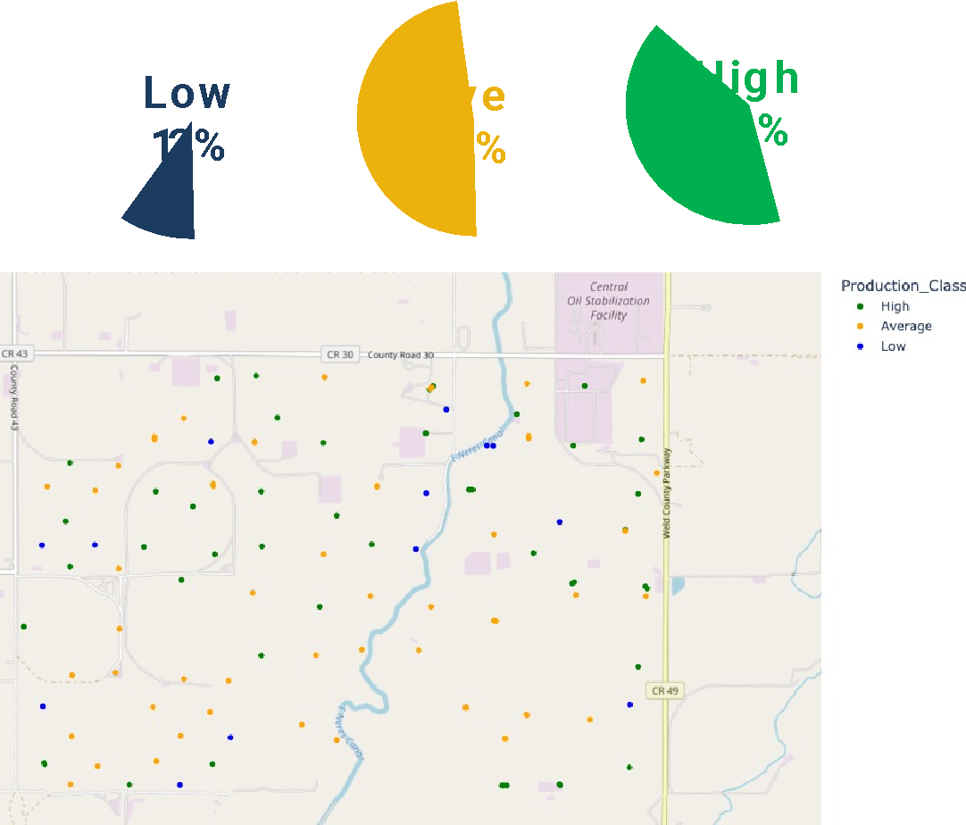

*Figure 11: Production Classification Locations*

The quadrant analysis of well production in the Wattenberg Field has yielded insights that are pivotal for strategic drilling decisions. The data indicates that the South-East and North-East quadrants should be prioritized for new drilling ventures due to their higher median production rates and the presence of several high-performance wells. Conversely, strategies to enhance recovery in the South-West and stabilize production in the North-West could further leverage the field's overall potential.

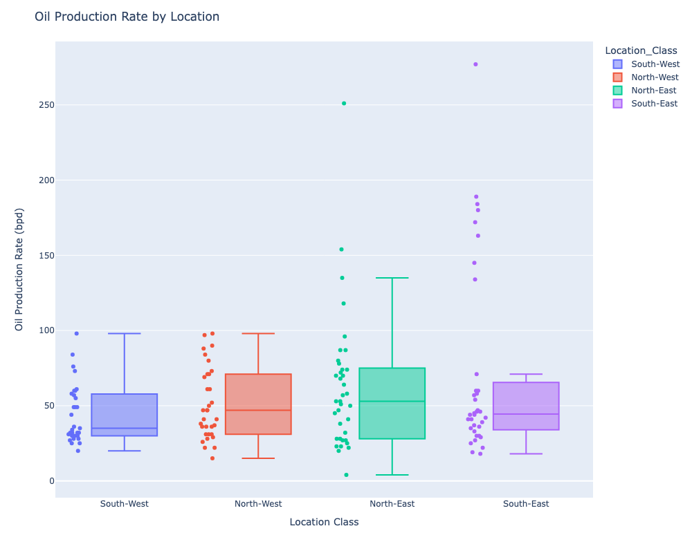

*Figure SEQ Figure \* ARABIC 12: Production per Quadrant*

## **Correlation Matrix**

To have a comprehensive understanding of the factors influencing oil production rates in the Wattenberg Field, a heatmap was utilized to visualize the correlations between oil production and various geostatistical parameters. The heatmap shows the following insights:

* **Porosity:** There is a strong positive correlation of 0.82 between porosity and oil production. This high correlation suggests that porosity is a critical factor in predicting oil production rates. Areas with higher porosity are more likely to yield higher oil production, making it a significant parameter for evaluating potential drilling locations.
* **Water Saturation:** The correlation between water saturation and oil production is negative, at -0.66. This inverse relationship implies that as water saturation increases, the potential for oil production decreases. Therefore, we should target areas with lower water saturation to enhance the likelihood of oil recovery and minimize water production.
* **Permeability:** A positive correlation of 0.67 was observed between permeability and oil production. Although this suggests that higher permeability can be associated with increased oil production, the overall low permeability characteristic of the field indicates that it might not have a great impact on the production.

The analysis highlights the need to prioritize geological zones that have higher porosity and permeability while maintaining lower water saturation levels. Such zones are more likely to contribute to initial production figures and offer sustained production over time, thereby maximizing the field's output and extending the profitability horizon of any new wells drilled.

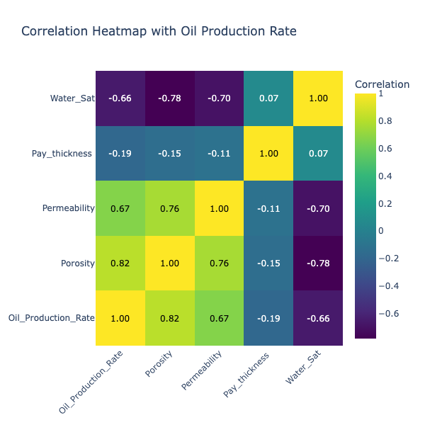

*Figure 13: Correlation Matrix*

## PROPOSED LOCATION FOR INFILL DRILLING

To select the ideal drilling location for a new well, a strategic approach was implemented to extrapolate limited geostatistical data across the area of interest. This methodological step is vital to project the data points from the drilled wells onto the entire field, ensuring a data foundation for making informed decisions on where to drill next.

* Reflecting the correlation matrix and volumetric equation findings, locations with high porosity and greater reservoir thickness are prioritized. These factors are directly linked to the potential oil volume within the reservoir.
* Locations with lower water saturation to be targeted to enhance oil recovery and avoid excessive water production, which can be detrimental to well economics.
* Although permeability is a critical factor in reservoir quality, the low values across the field suggested a minimal impact on production rates. Therefore, it was excluded from the primary selection criteria.
* To reduce the risk associated with new wells, the chosen location is strategically surrounded by high-performing wells, leveraging the likelihood of encountering similar productive geology.

Given the limited geostatistical data restricted to existing wells, we adopted an interpolation method to populate the necessary data throughout the area of interest. This was crucial in visualizing potential drilling locations across the entire field, not just where we currently have well data. This includes linear techniques and nearest-neighbor estimations, which were utilized to infer missing data points. This ensured a seamless and continuous dataset for critical parameters like porosity and water saturation, enabling a comprehensive analysis of the field. Then, with a full set of interpolated geostatistical data, we could visualize the field's subsurface characteristics. This visualization facilitated the identification of sweet spots—areas with ideal geological attributes for oil extraction.

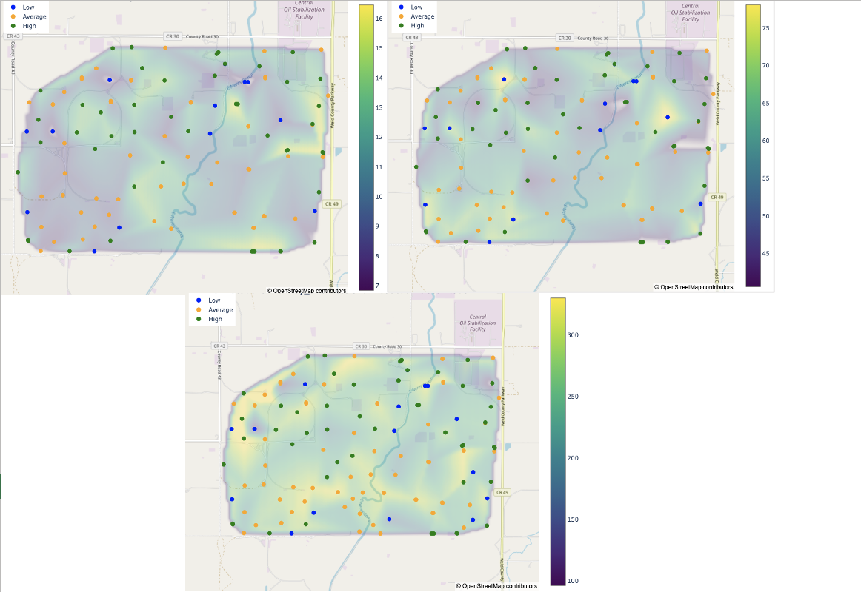

*Figure 14: Proposed drilling location*

On the north-eastern quadrant of the area of interest, a potential location has been selected for its geostatistical characteristics that align with our criteria for optimal drilling conditions. The selected site has a high porosity of around 14%, indicating a reservoir rich in pore spaces for oil storage, paired with a low water saturation of 48%, which promises a higher proportion of recoverable oil. Additionally, the substantial thickness of over 200 feet reservoir contact. Additionally, this location is located between high-producing wells, suggesting a geologically favorable setting for oil extraction and minimizing the risk associated with new drilling operations. The combination of these factors—optimal porosity, minimized water saturation, significant thickness, and proven surrounding productivity—converges to make this site a prime candidate for drilling, with the expectation of high oil output and economic profit.

## **OIL PRODUCTION RATE PREDICTION**

To optimize oil production within the area in Wattenberg Field, we have employed regression analysis to predict oil production rates. Our regression analysis aims to establish a predictive model for oil production based on geostatistical data. This method is pivotal in evaluating the viability of prospective drilling sites within the field. Porosity has been selected as the primary variable with a direct and statistically significant influence on oil production. The model indicates that a one percent increase in porosity corresponds to an approximately 13.67-barrel rise in daily oil production. The regression model, with an R-squared value of 0.667, indicates a strong model fit. The coefficient for porosity is 13.67 with a p-value < 0.001, which indicates that porosity is a statistically significant predictor of oil production rate.

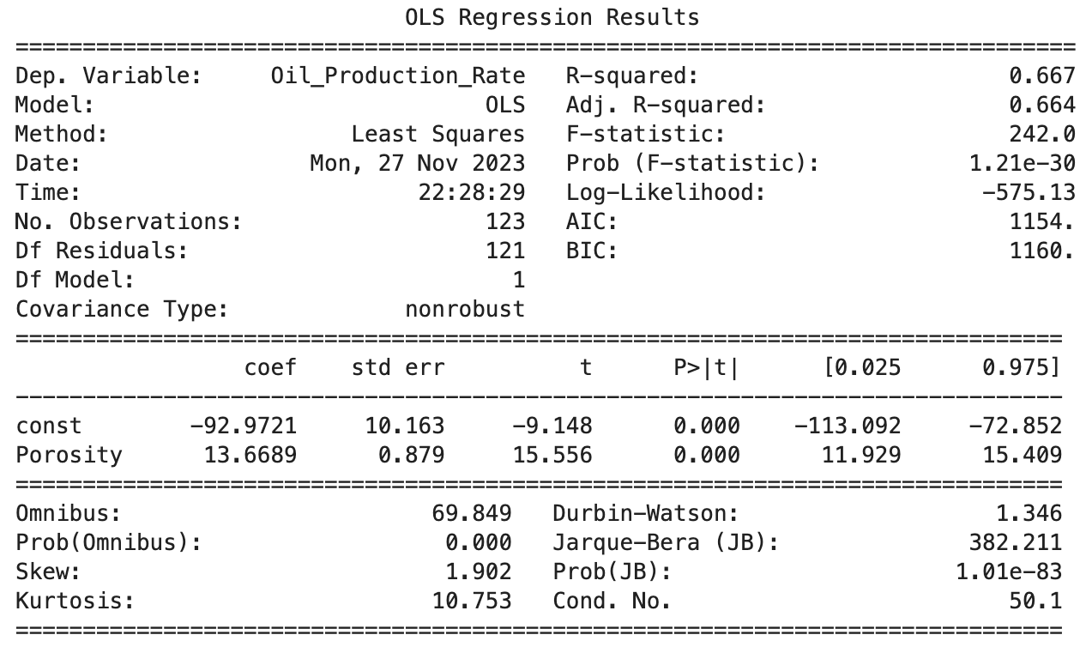

*Figure 15: Regression with Porosity*

The plot below illustrates a trend consistent with the regression findings, but with less precision at higher porosity values. This discrepancy suggests outliers or unaccounted factors, possibly pressure dynamics, well interventions, or other undisclosed variables, could be influencing the higher end of production rates. These elements, while beyond the scope of our current dataset, highlight the complexity of reservoir behavior.

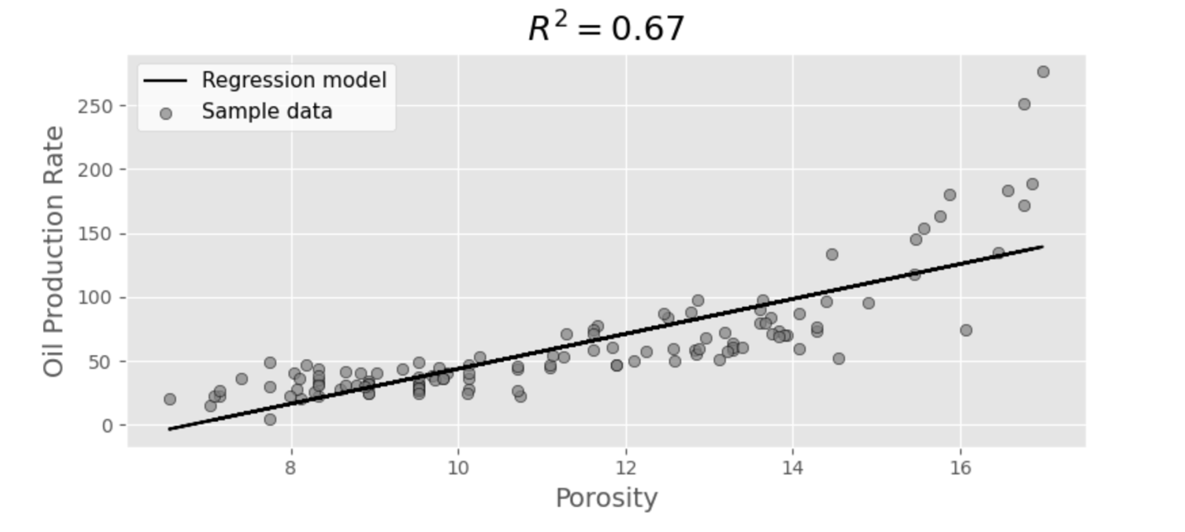

*Figure 16: Regression Plot - Porosity*

* **Model with Multiple Variables:** When incorporating additional variables such as pay thickness, permeability, and water saturation, the adjusted R-squared value slightly increases to 0.665. This suggests that these variables individually do not significantly enhance the model’s predictive capability. Analysis of Individual Variables in Extended Model:
  + **Pay Thickness:** The coefficient for pay thickness is -0.0877, with a p-value of 0.179. This indicates that there is no statistically significant relationship between pay thickness and oil production rate in this model.
  + **Permeability:** The coefficient for permeability is 13.1899, yet it is not statistically significant (p-value = 0.250), suggesting that permeability is not a reliable predictor of oil production rate within this dataset. In addition, the permeability was indicated to be low and rock is tight, supporting this insight.
  + **Water Saturation:** Similarly, water saturation has a coefficient of -0.1299 with a high p-value of 0.755, indicating that it does not have a statistically significant impact on oil production rate.

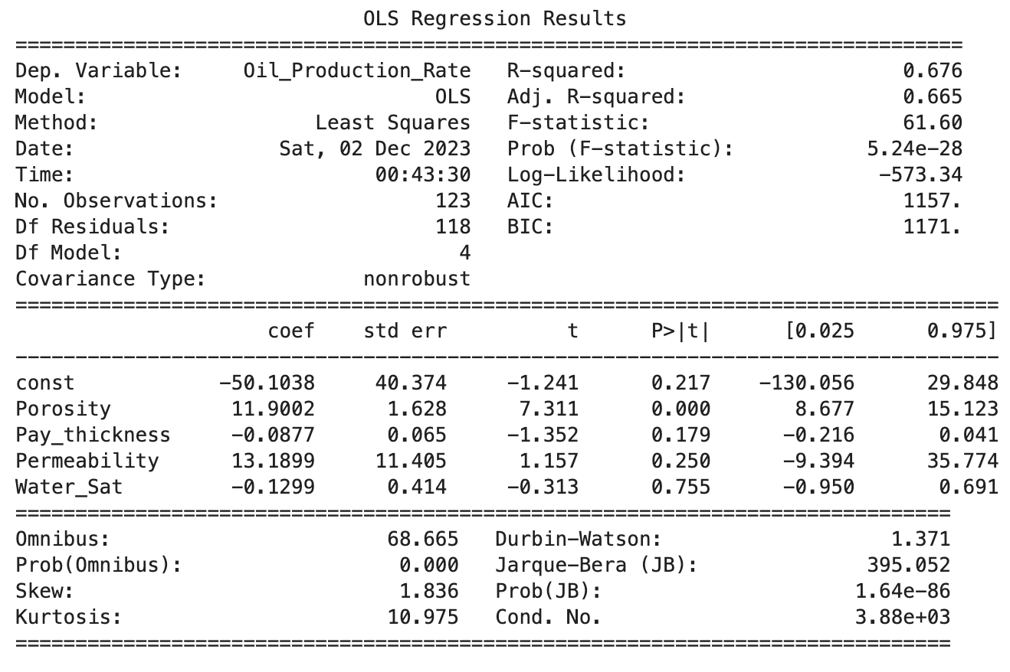

*Figure 17: Regression with All Factors*

Given the data constraints, our analysis is kept to using porosity as the only variable for predicting oil production rates. This decision is supported by statistical significance. Predicting the production of the proposed location, a 100 bpd is estimated to be produced having this as high producing location and producing higher than the field average by 72%.

## **ECONOMIC ANALYSIS**

The ultimate goal of this model is to aid an operator in becoming more profitable. An economic analysis was completed to give a net present value of drilling the proposed location. This estimate involves multiple assumptions and estimates and further analysis is required as there are factors that affect the cost of oil, the production decline and taxes and royalties calculation based on the total amount that an operator is producing. For the purpose in this project, we provided an overview of the process of selecting a location and an overview of the costs associated with oil drilling and production. The economic model for this project is designed to guide operators towards higher profitability by evaluating the viability of drilling at a proposed location. The analysis have several assumptions:

1. **Oil Price**: Given the fluctuating nature of oil prices influenced by global economic and political events, a conservative estimate of $75 per barrel is adopted for a five-year forecast. This price point serves as a conservative figure, accommodating potential variations in the market based on several studies (eia & JP Morgan).
2. **Production Estimate**: The model assumes a steady production rate of 100 barrels per day (bpd) over the five-year period, providing a baseline for revenue projections without accounting for potential decline rates or production increases.
3. **Operating Costs**: Drawing from industry reports and direct communications with regional operators, the operating cost is estimated at $6.00 per barrel for wells within the area of interest.
4. **Taxes, land and Royalties**: Calculated at 33% (15% tax, 15% Royalties & 3% land), this figure is informed by the U.S. Department of the Interior's guidelines, reflecting the combined burden of statutory taxes and royalties due to the state.
5. **Discount Rate:** The net present value (NPV) calculation incorporates a discount rate of 4.75%, representing the time value of money and investment risk.
6. **Drilling Costs:** The capital expenditure for drilling and related activities is estimated at $2 million, benchmarked against expenses for similar wells in the vicinity.
7. **Profit Analysis:** The projected **NPV of close to $7 million** over five years indicates a good return on investment, outperforming the field's average production scenario (58 bpd) by approximately $4 million.

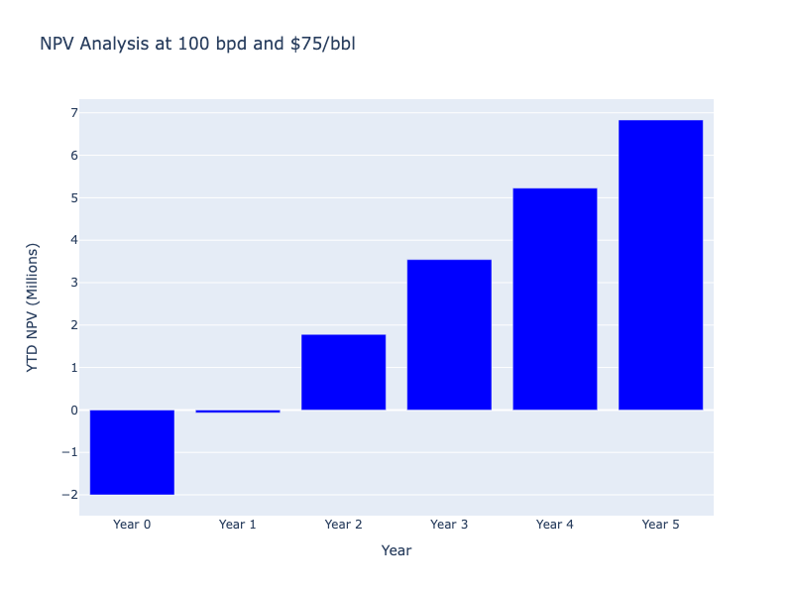

*Figure 18: NPV at Year 5 with 100 bpd & $75/bbl*

Below summarize the equations used to calculate NPV:

$$Annual Revenue=daily oil production rate× 365 × Ave oil price$$

$$Operating Cost=daily oil production rate× 365 × operating cost per bbl$$

$$Royalties=Revenue× Royalties Rate$$

$$Land Cost=Revenue×Land Rate$$

$$Deductions=operating cost+ land cost+royalties$$

$$Profit=Annual Revenue -Deductions$$

$$Tax=Profit × Tax rate$$

$$Profit_{after tax}=Profit -Tax$$

$$Yearly NPV=\frac{Profit_{after tax}}{{\left(1+discount rate\right)}^{year}}$$

For year zero, only drilling related cost is calculated with negative value.

$$Year to Date NPV= \sum{}NPV$$

Operating cost

1. **Break Even Analysis:** At the predicted production rate, the breakeven oil price is calculated to be $23 per barrel at the end of the five-year period, suggesting an economic buffer against price volatility.

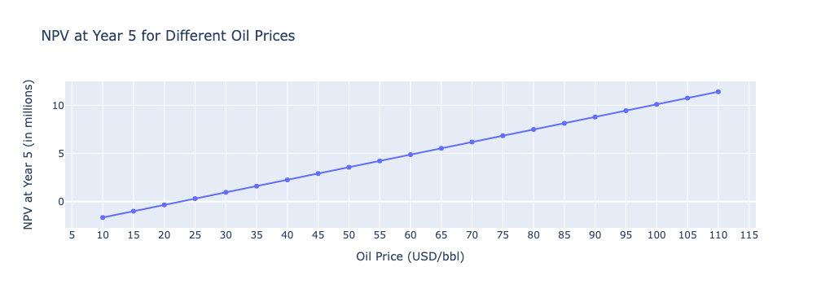

*Figure 19 NPV at year 5 at different oil price average*

This economic assessment is built on hypotheticals and approximations. Variables such as oil price trajectories, production decline rates, varying tax and royalty obligations, and differential production scales all necessitate a more in depth analysis. The primary intent here is to have a foundational framework for evaluating drilling prospects, providing a preliminary financial outlook on the exploration and extraction of oil drilling.

# **CONCLUSION**

The analysis of the Wattenberg Field's geostatistical and production data represents a comprehensive effort to distill a significant amount of information into actionable insights for oil well drilling. Here's a detailed look into the methodology and its limitations:

**1. Descriptive and Correlation Analysis** The project initiated with an analysis of existing well data, establishing a clear picture of the field's performance. Key findings from this phase included:

* A median oil production rate of 46 bpd and average of 58 bpd, which exceeds the national average.
* Porosity demonstrates the highest correlation with oil production at a factor of 0.82, suggesting it as a primary driver for oil extraction.

**2. Geostatistical Data Estimation and Drilling Location Selection** The subsequent challenge was to extrapolate geostatistical data for undrilled areas. Through interpolation, we populated the field with estimated values for porosity and water saturation. The selection criteria for drilling sites emphasized:

* High porosity and thickness for maximum oil volume.
* Low water saturation to reduce water cut and enhance oil recovery.
* Proximity to high producing wells.

**3. Production Projection and Economic Feasibility** Using regression models, we projected oil production rates based on porosity due to its statistical significance. The economic model, which considered an average oil price of $75/bbl and a production rate of 100 bpd, estimated a substantial NPV of $7 million over five years.

**Limitations of the Analysis** While the methodology provided generic estimates, several limitations are noteworthy:

* The absence of dynamic production data such as pressure, viscosity, and depletion rates prevented a comprehensive analysis.
* Lack of access to time-series data meant that a decline curve analysis, which could offer insights into the wells' future performance, was not feasible.
* The heterogeneity of the field and varying rock qualities could affect the accuracy of the geostatistical estimations and production projections.

In conclusion, while the study provided valuable predictions and economic assessments, it was constrained by the available static data. The findings highlight the need for more dynamic reservoir data and advanced analytical techniques like decline curve analysis for a more understanding of well performance over time. Future studies incorporating these aspects could enhance the predictive accuracy and economic assessments, guiding better-informed decisions in oil field development.

# **References**

Colorado Oil and Gas Conservation Commission

<https://ecmc.state.co.us/data.html>

Salama, A., El Amin, M. F., Kumar, K., & Sun, S. (2017). Flow and Transport in Tight and Shale Formations: A Review. *Hindawi Geofluids*, *2017*, Article ID 4251209, 21 pages. <https://doi.org/10.1155/2017/4251209>

Dechongkit, P., & Prasad, M. (2011). Recovery Factor and Reserves Estimation in the Bakken Petroleum System (Analysis of the Antelope, Sanish and Parshall fields). Paper presented at the Canadian Unconventional Resources Conference, Calgary, Alberta, Canada, 15-17 November 2011. CSUG/SPE 149471.

Stamer, J. D. (Year). GEOLOGIC RESERVOIR CHARACTERIZATION OF THE CODELL SANDSTONE: CENTRAL WATTENBERG FIELD, COLORADO [Master’s thesis, Colorado School of Mines]. Colorado School of Mines Repository.

<https://repository.mines.edu/bitstream/handle/11124/170108/Stamer_mines_0052N_10996.pdf?sequence=1>

U.S. Energy Information Administration. (2022). [The Distribution of U.S. Oil and Natural Gas Wells by Production Rate]. Retrieved from <https://www.eia.gov/petroleum/wells/pdf/full_report.pdf>

U.S. Department of the Interior.Revenue Streams in Colorado [PDF file]. Retrieved from <https://revenuedata.doi.gov/downloads/archive/USEITI_Colorado_revenue_streams.pdf>

U.S. Geological Survey. (2011). [Gas, Oil, and Water Production from Wattenberg Field in the Denver Basin, Colorado] (U.S. Geological Survey Open-File Report No. 2011-1175). Retrieved from <https://pubs.usgs.gov/of/2011/1175/pdf/OF11-1175.pdf>

Earth Point, Inc. (n.d.). Township and range Search by description. Copyright 2005 - 2023 by Earth Point, Inc. <https://www.earthpoint.us/townshipssearchbydescription.aspx>

Short-Term energy outlook - U.S. Energy Information Administration (EIA). (n.d.). <https://www.eia.gov/outlooks/steo/>

StackPath. (n.d.). <http://www.pdce.com/operations-overview/wattenberg-field/>

US oil and gas wells by production rate - U.S. Energy Information Administration (EIA). (n.d.). <https://www.eia.gov/petroleum/wells/#:~:text=The%20number%20of%20producing%20wells,rig%20activity%20(Figure%201)>.

Zhao, S., Zhou, Y., Wang, M., Xin, X., & Chen, F. (2014). Thickness, porosity, and permeability prediction: comparative studies and application of the geostatistical modeling in an Oil field. Environmental Systems Research, 3(1), 7. <https://doi.org/10.1186/2193-2697-3-7>

Organization of the Petroleum Exporting Countries. (2023). World Oil Outlook 2045.

<https://www.opec.org/opec_web/en/press_room/7225.htm>